# Case Study Week 8: Dairy Cattle

Consider the following image from a seasonal calving dairy farm in western Victoria.

The dairy enterprise is a seasonal calving dairy herd milking 658 cows in a rotary dairy with a mating start date (MSD) of 22nd August.

Normal practice is that cycling cows are synchronised with a fixed-time insemination program. Cows are joined to AI from Mating Start Date for 6 weeks, and then mop up bulls are used for a further 6 weeks. The typical period of post-partum anoestrus on this farm lasts 30 days.

What is meant by a “seasonal calving dairy herd” and what are the alternative types of calving pattern?

|  |
| --- |
| Seasonal: One calving period per year, typically 8-12 weeks  Split: 2-3 calving periods per year usually shorter 3-4 weeks  Year-round – Calving all year round |

How typical is this farm of dairy farms in western Victoria in terms of calving pattern, herd size, dairy type etc?

|  |
| --- |
| Average herd size About 300  Mostly split calving  Dairy type varies |

The following image describes the calving pattern for the farm:

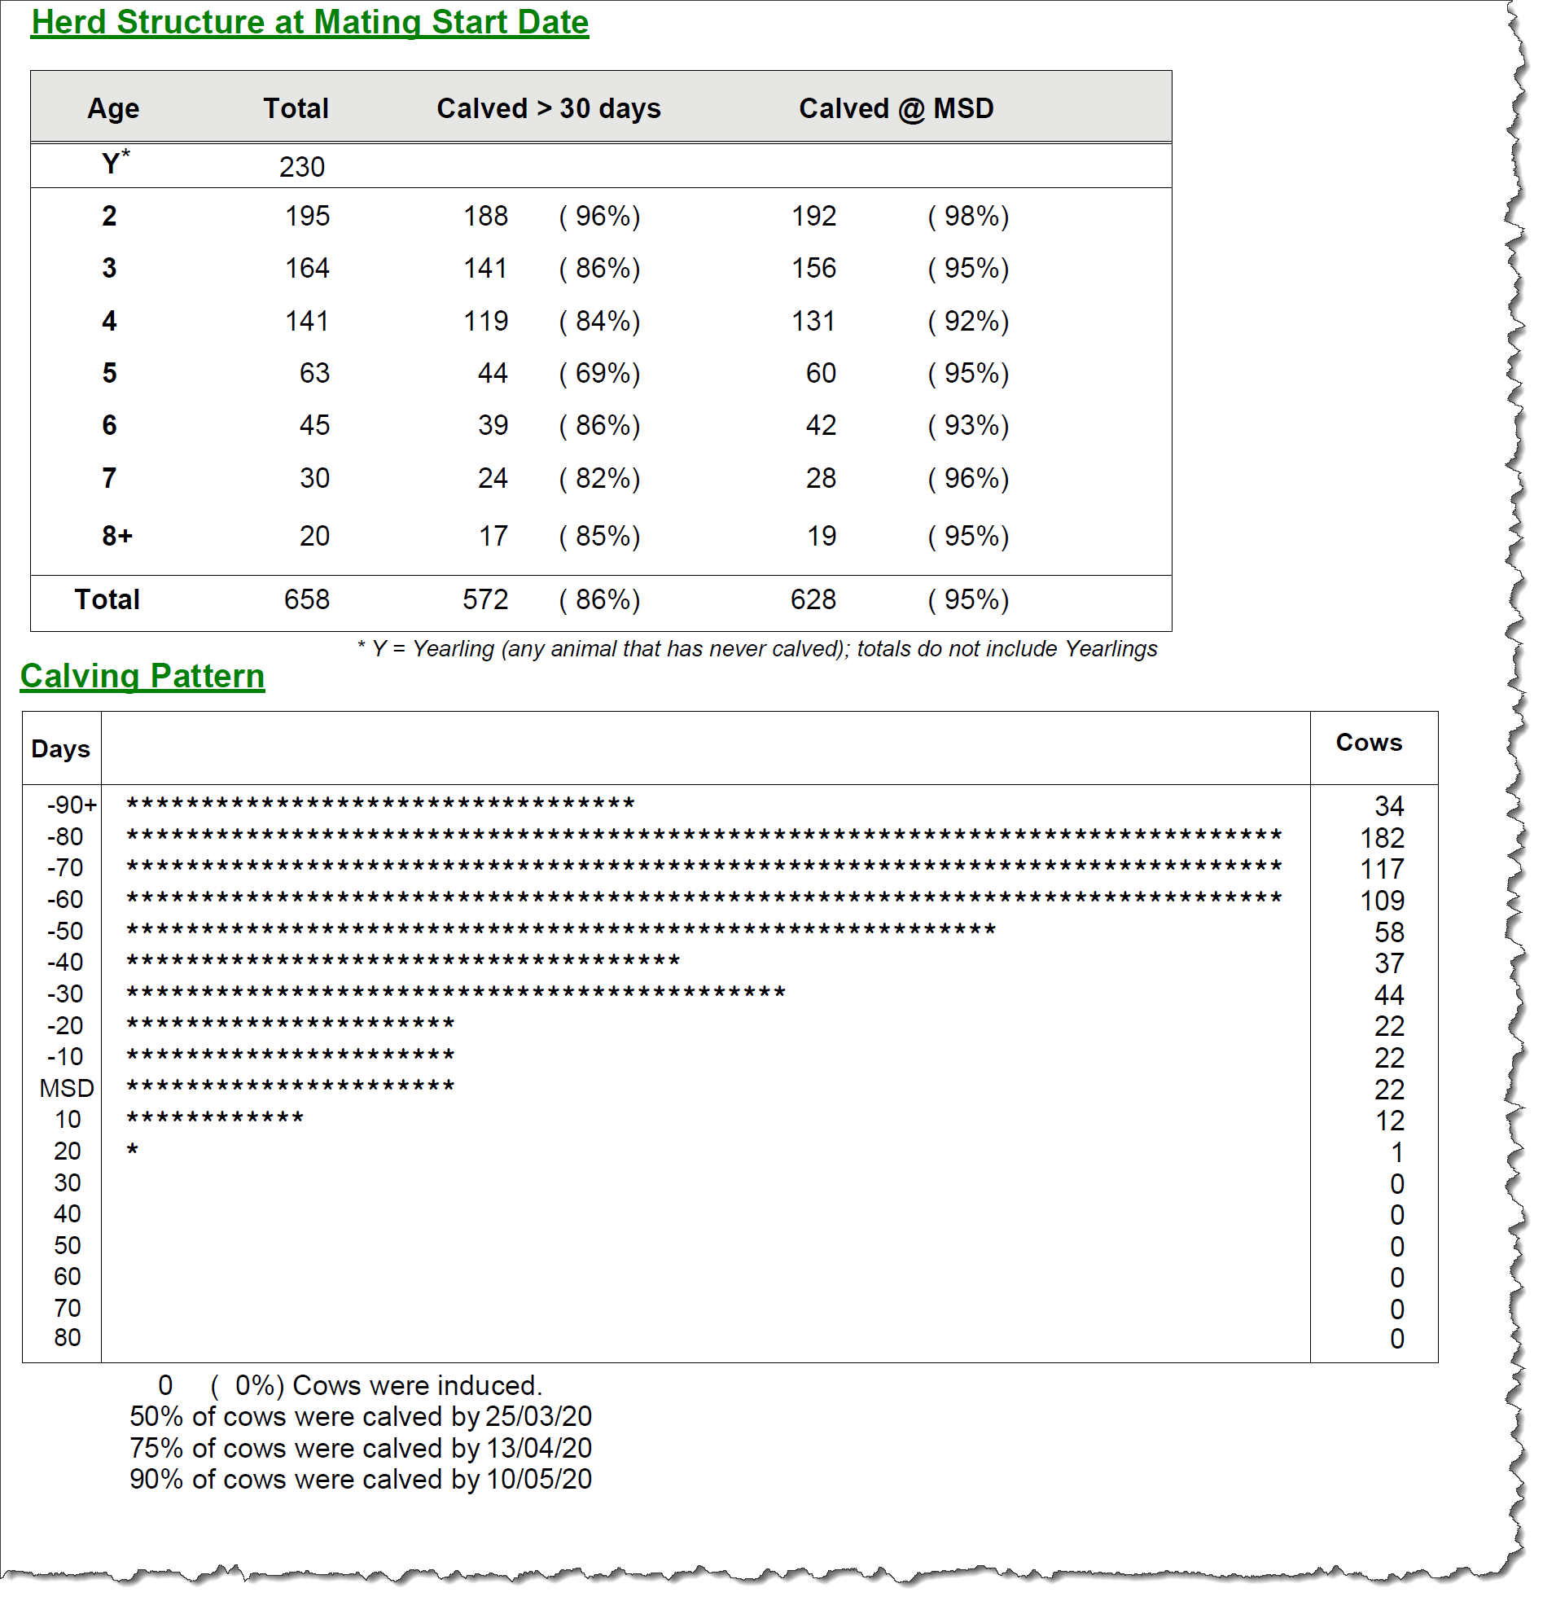

Estimate how many cows you think would be cycling at MSD?

|  |
| --- |
| 86% |

When did the calving period above start?

|  |
| --- |
| 1st June |

Assume that the conception pattern during the mating period produces an expected calving pattern similar to the calving pattern above.

Estimate how many of each class of stock you think would be on the farm on the first of each month starting from calving start date?

|  |  |  |  |
| --- | --- | --- | --- |
|  | Milkers | Dry Cows | Calves (0-1yo) |
| June 2021 | 0 | 658 | 0 |
| July 2021 | 34+182+117=333 | 658-333=325 | 333/2=160 |
| August 2021 | 333+109+58+37=537 | 658-537=121 | 537/2=268 |
| September 2021 | 537+44+22+22=625 | 658-625=33 | 326?? |
| October 2021 | 658 | 0 |  |
| November 2021 |  |  |  |
| December 2021 |  |  |  |
| January 2022 |  |  |  |
| February 2022 |  |  |  |
| March 2022 |  |  |  |
| April 2022 |  |  |  |
| May 2022 | 325 | 333 |  |
| June 2022 | 121 | 537 |  |
| July 2022 | 33 | 625 |  |

Produce a management calendar showing the dates of:

* Calving start and end
* Mating start and end – including when bulls and AI are used
* Dry period start and end

|  |
| --- |
| 1/6 Calving start  22/8 calving end, mating start  22/10 ai end, bull start  22/11 bull end  2/4 dry off start  22/6 dry off end |